11/6/2017



**Research Document**

**Safe​ ​and​ ​Independent​ ​living​ ​for​ ​elderly​ ​people​ ​ (Ambient​ ​Assisted​ ​Living)**

**Student Name: Frank Rooney**

**Student ID: C00196890**

**Supervisor: Hisain​ ​Elshaafi**

# Abstract

THE AIM OF THIS DOCUMENT WAS TO OUTLINE THE TECHNOLOGIES AND FRAMEWORK RESEARCHED FOR THIS PROJECT. THE METHODOLOGY AND RATIONAL BEHIND WHAT TECHNOLOGIES THAT WHERE CHOSEN AND WHY.

RESEARCH WAS ALSO CARRIED OUT IN RELATION TO ALZHIEMER’S DISEASE AND THE IMPACT THAT INTERACTION AND STIMULATION CAN HELP SLOW THE PROCESS OF DEMENTIA.

HOW THE IDEA FOR THE PROJECT WAS TO PLAY A SMALL PART IN THE BATTLE TO BRING SOME COMFORT TO AN EVER-INCREASING POPULATION OF ELDERLY PEOPLE WHO SUFFER FROM THIS PROGRESSIVE AND INCURABLE DISEASE.

Table of Contentss

[Abstract 1](#_Toc498624042)

[Introduction 3](#_Toc498624043)

[Research objectives 3](#_Toc498624044)

[Literary review 3](#_Toc498624045)

[Project Aim 4](#_Toc498624046)

[Native, Non-Native and Hybrid Apps 4](#_Toc498624047)

[Summary 4](#_Toc498624048)

[Medical Insight 5](#_Toc498624049)

[Comparable Applications 5](#_Toc498624050)

[Lumosity (Android iOS) 5](#_Toc498624051)

[Elevate (Android iOS) 6](#_Toc498624052)

[Peak (iOS) 6](#_Toc498624053)

[MindMate (iOS) 7](#_Toc498624054)

[More Comparable Applications (links). 7](#_Toc498624055)

[Comparison chart 8](#_Toc498624056)

[Compared Applications Conclusion 8](#_Toc498624057)

[Technology and Framework 9](#_Toc498624058)

[Android Studio 9](#_Toc498624059)

[Firebase 9](#_Toc498624060)

[Ionic 10](#_Toc498624061)

[Azure 10](#_Toc498624062)

[PythonAnywhere 11](#_Toc498624063)

[MongoDB 11](#_Toc498624064)

[Django 12](#_Toc498624065)

[Bulma 12](#_Toc498624066)

[MySQL 13](#_Toc498624067)

[Technology and Framework conclusion 13](#_Toc498624068)

[BIBLIOGRAPHY 14](#_Toc498624069)

# Introduction

This research document will outline to the reader the methodology used to solve a software problem within the subject of Ambient Assisted Living in the form of a project. One of the problems Ambient Assisted living is facing on a global scale is the population growth of the elderly.

It is important to note that present day advances in medicine have led to people living longer and healthier lives compared to those of a previous generation. The aim of Ambient Assisted living (AAL) is to create technology programmes the will greatly improve the quality of life of older people [1]

## Research objectives

The overall objective of this research is to outline and evaluate the different technologies and frameworks to find a balance between client and server requirements to coincide with and resolve the issues raised within the project aim.

# Literary review

With technology (AAL) has the potential to predict and react to the different stages of getting old. However (AAL) technology has barely concentrated on older people who are healthy, frail or suffering from early stages of dementia. [2]

People who suffer from dementia are challenged with a disorder that progressively overwhelms their ability to carry out daily activities, affecting memory, behaviour and thinking. Current treatments for neurodegenerative conditions are limited to the treatment of symptoms rather than cause. In the past 5 years there has been no new drug approval for Alzheimer’s. Dementia has an average life span of around two to ten years, this can range between mild cognitive impairment to severe Alzheimer’s. Dementia also has an impact on the carers and families of those people who have the condition. (AAL) greatly increases support for people of dementia their families and carer network both voluntary and professional [3]

“***Alzheimer's disease typically progresses slowly in three general stages — mild (early-stage), moderate (middle-stage), and severe (late-stage)”.***

This Project will look at one of these stages of Alzheimer’s, The mild (early-stage).

Overview of early-stage

People who are diagnosed with early-stage or mild Alzheimer’s may still be able to function alone or unaccompanied an example of this could be driving, working or social activities. Although they may experience slight loses in memory such as forgetting familiar words or the whereabout of everyday items. **[4]**

## Project Aim

Therefore, aim of the project is to develop a web application for tablet or mobile which will incorporate a recall of memories activity to enhance the lives of those suffering from early stage Alzheimer’s. The application activity will consist of images loaded onto the system by a family member or carer along with a set of predefined questions and answers directly related to the loaded images. The questions will be designed in such a way that the user will be given an image and a question with three possible answers, one of which is correct. The answers will then be displayed at the end and will be scored on each level. This data gathered from the answers will be stored in a database which can be reproduced in chart form for analysis of the users progress or decline. The levels can be set by the administrator (family member or carer) these images may be old photos or current trips which can be uploaded via wireless connectivity directly from camera or via the tablet itself. A simple touch screen or voice activated interface to allow for ease of use and to deter any fear of technology by the possibility of the non-tech savvy user. A family member voice over option to help comfort and familiarise the user.

# Native, Non-Native and Hybrid Apps

## Summary

Native apps live on the device are installed from an App store such as” Google Play”. Can take advantage of device features like the camera or GPS. Usually accessed by a specific icon on the home screen.

Non-native are essentially website made to look and feel like a web app. Written in HTML5 and are run by a browser

Hybrid is what the word implies it a combination on native and non-native. Lives on the device and can also take advantage of device features but rely on Html to render in a browser. [19]

# Medical Insight

[Sensory stimulation](http://shadowboxpress.wordpress.com/2013/06/07/sensory-stimulation-to-engage-alzheimers-patients/) uses everyday objects to arouse the senses and memories in seniors who have lost their ability to link with the world around them. As far back as the 1960s, this therapy was formally designed to help people with learning difficulties.

With Alzheimer’s disease, an elderly person’s ability to communicate and perform everyday activities progressively diminishes. Giving these seniors means to express themselves, can improve mood and well-being along with their self-esteem when they can no longer do so with words. Also, it is important that they feel safe and relaxed.

*“For instance,*[*art or photos*](http://www.aplaceformom.com/blog/2013-10-31-art-therapy-good-for-brain/)*can trigger emotions and memories for seniors who no longer speak. A senior who has not expressed a word in months might suddenly smile or want to pick up a pencil and draw. That art form eventually can become a means for the senior to communicate, either through personal works of art or simply by sharing the experience.”*

[20]

# Comparable Applications

## Lumosity (Android iOS)

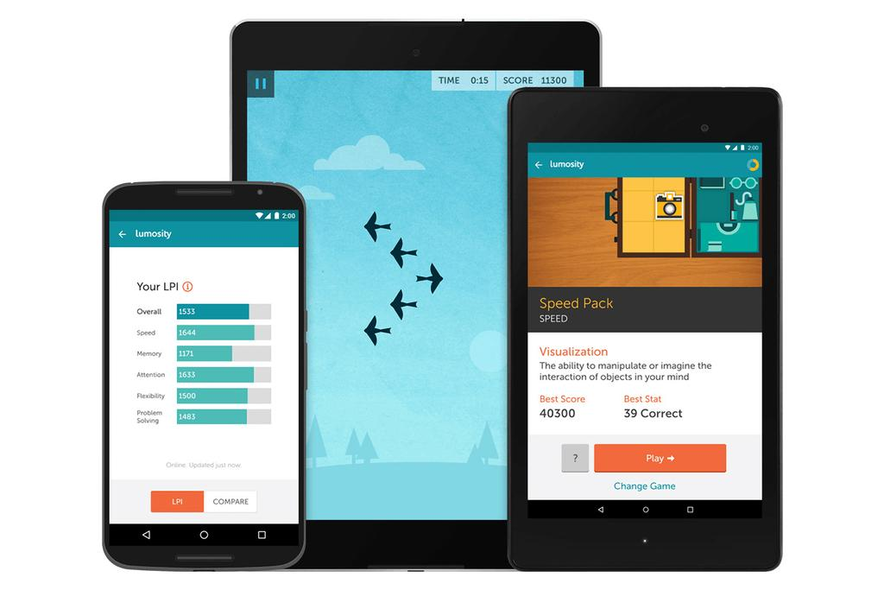Nicknamed by its founder Kunal Sakar “*Gym for The Brain*” This APP focuses on patterns and shapes as a way of training the user and enhancing their skill set. This App comes with three free games initially further games can be unlocked with subscription. [5][6]

Figure LUMOSITY

## Elevate (Android iOS)

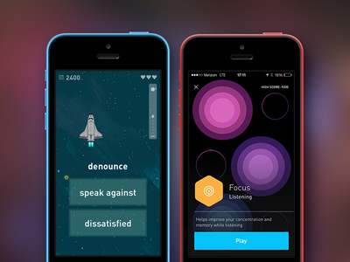Design to improve attention skills while using spoken or written text. Training will adjust over time. Games vary from correcting grammar to listening skills. Initially comes with 16 free games which alternate daily. [5]

Figure [7] ELEVATE

## Peak (iOS)

Figure [9] PEAK

The objective of Peak is to provide the user with engaging and rewarding games that will question and enhance cognitive ability. Developed by experts. Challenges your mental agility, problem solving, memory and cognitive skills. Comes initially with 30 games. [8]

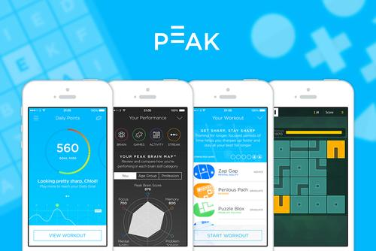

## MindMate (iOS)

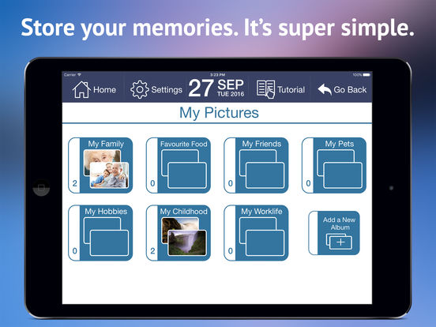Initially come with eight games especially designed with Alzheimer’s and dementia in mind. The aim is to assist in having fun while keeping the user independent for as long as possible. Reminder to take pills, brush teeth and more importantly to eat. This is also an aide to family and carers alike.

Figure [9] MINDMATE

## More Comparable Applications (links).

[Alzheimer’s Disease Pocketcard](https://itunes.apple.com/us/app/alzheimers-disease-pocketcard/id845039544?mt=8&at=10laz6&ct=applist_free" \t "_blank)  
[Peak - Brain Training](https://itunes.apple.com/us/app/peak-brain-training/id806223188?mt=8&at=10laz6&ct=applist_free)

[Spaced Retrieval Therapy - Memory Training for Dementia & Brain Injury](https://itunes.apple.com/us/app/spaced-retrieval-therapy-memory/id498787795?mt=8&at=10laz6&ct=applist_free)

[Amyloids](https://itunes.apple.com/us/app/amyloids/id1057927225?mt=8&at=10laz6&ct=applist_free)

[Alzheimer's & Other Dementias Daily Companion - An extension of the book: Confidence to C](https://itunes.apple.com/us/app/alzheimers-other-dementias/id696976537?mt=8&at=10laz6&ct=applist_free)

[Alzheimer's Society's Talking Point forum](https://itunes.apple.com/us/app/alzheimers-societys-talking/id651419467?mt=8&at=10laz6&ct=applist_free)

[Precision Medicine Alzheimer's](https://itunes.apple.com/us/app/precision-medicine-alzheimers/id1048951028?mt=8&at=10laz6&ct=applist_free)

[Nudgu Reminders](https://itunes.apple.com/us/app/nudgu-reminders/id1065969940?mt=8&at=10laz6&ct=applist_free)

[HABC](https://itunes.apple.com/us/app/habc/id849139893?mt=8&at=10laz6&ct=applist_free)

## Comparison chart

|  |  |  |  |  |  |  |
| --- | --- | --- | --- | --- | --- | --- |
|  | Platform  Types | Assessment tools | Brain  Games | Reminder  Tools | Assist  Carers | Memory  Photo Galley |
| Mind-mate | IOS Android | ✓ | ✓ | ✓ | ✓ | ✓ |
| Elavate | IOS Android | ✓ |  |  | ✓ |  |
| Peak | IOS Android | ✓ | ✓ |  | ✓ |  |
| Lumosity | IOS Android | ✓ | ✓ |  |  |  |
| Pocketcard | IOS Android |  | ✓ |  |  |  |
| Spaced | IOS Android | ✓ | ✓ | ✓ | ✓ |  |
| Amyloids | IOS Android | ✓ | ✓ |  |  |  |
| Alz Daily | IOS Android |  |  |  | ✓ |  |
| Talking point | IOS Android |  |  |  | ✓ |  |
| Precision Med | IOS Android | ✓ |  | ✓ | ✓ |  |
| Nudgu | IOS Android |  |  | ✓ | ✓ |  |
| Habc | IOS Android |  |  |  | ✓ |  |

## Compared Applications Conclusion

The findings from the research are that there are many applications for Alzheimer’s and dementia. They all have similar functionality and are geared towards brain training and cognitive assessment through a series of games. Some are specifically designed by the Alzheimer’s Society as a forum to share experiences with people associated with the disease to help solve common problems.

Although these apps are geared towards helping people remember I believe there is gap in this area of elderly people where they are isolated or alone. Possibly in a care home and don’t get to see their families too often. These is a need for an application to just share an old memory, family photos or easy way to connect to a loved one to break the cycle of loneliness. Some elderly people may not be able to use a brain quiz simply because they are too old. It is important to note the comparison chart shows only one application using images which is the main features of this project.

**Some elements of the research I may incorporate in the project**

Voice recognition

Reminders

Note sharing between family and carer

Favourite music play list

# Technology and Framework

## 



## Android Studio

Constructed on JetBrains' IntelliJ IDEA software and designed specifically for Android development. Can run on different types of operating systems Windows, macOS and Linux. Android Studio is the official integrated development environment (IDE) for Google's Android operating system. Supports Google Cloud Platform, simplifying the integration with Google Cloud Messaging and App Engine. [10]

Pros:

* A one for all environment where all Android devices can be developed
* Instant Run to push changes to your running app without building a new APK
* Large scale tools for testing including emulator.

Cons:

* Constant updates can create app instability
* Primarily build for android app development



## Firebase

A cloud-hosted database in Realtime. Data is stored as JSON and synced to every connected client. This mean if your apps are built with our iOS, Android, and JavaScript SDKs, all your users share one Realtime Database. Firebase stores the data as JSON. It has a NoSQL database which allows for different optimizations and functionality compared to a SQL or relational database. [11]

**Pros:**

* Comes with back end infrastructure
* User authentication included

**Cons:**

* As data will be stored in Json may be better solutions if your data is well structured
* Hard to migrate to another hosting service if something fails or shuts down

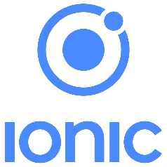

Ionic is an open-source and robust HTML5 SDK for hybrid mobile app development. Created for cross platform and comes with AngularJS for ultimate UI enhancement. Free and open source. To run as Native, it requires a Cordova or PhoneGap plugins.

**Pros:**

* Well documented (open source)
* One code base for multiply platforms
* Comes with UI builder as well as extensions and plugins

**Cons:**

* Requires AngularJS to work to full potential
* Currently lacking some native capabilities



## Azure

Used by professional IT developers to manage build and deploy applications. The only consistent Hybrid cloud available complete with DevOps and integrated tools on the market across data platforms. [13]

**Pros:**

* Tight security, has multiple compliance certificates
* Scalability

**Cons:**

* Requires management and maintenance (patches)
* Requires platform expertise.

## PythonAnywhere

Hosted by AmazonEC2 the powerful services from PythonAnywhere allow the user to create and deploy python programs easily in the cloud. Because PythonAnywhere runs on your browser it is possible to write your application from iPad, phone as well as computer. Unfortunately, this facility currently in beta for android.

**Pros:**

* One stop shop
* Scalability, quick setup and ready to go

**Cons:**

* Not supporting Android

## MongoDB



With both flexibility and scalability MongoDB has all you need for a document database. MongoDB uses JSON to store documents. High availability and horizontal scaling. Free and open source [15]

**Pros:**

* Json Documents making data easy to work with.
* Scalability (horizontal)

**Cons:**

* Consumes more memory.
* Traditional join queries not possible

## Django

Developed by the Django Software Foundation. Open source framework designed to create web application quickly for the advanced developer. Comes with lots of extras like Authentication, sit maps and more.

**Pros:**

* Tremendously fast
* Scalable
* Loaded with extras
* Secure
* SQL Injection

**Cons:**

* Using routing pattern specify its URL
* Based on Python. Not everyone likes Python

## Bulma

Open source CSS (Cascading Style Sheets) framework based on flexbox. Modular, only import what is required. Comes with templates for easy set up. Supported by GitHub. [17]

**Pros:**

* Very lightweight and easy to customise
* Requires only one CSS file
* Templates

**Cons:**

* This framework can be slow compared to pure CSS
* Still in development full version not yet available



## MySQL

Oracles MySQL is considered the world most popular free relational SQL database. A leading choice in web based applications. Data is stored in table format with rows and column configuration. Reliable and easy to use

**Pros:**

* Reliable and easy to use.
* Good support and documentation for integration
* Secure

**Cons:**

* Scalability, can be slow or problems occur with large queries
* Not completely open source

# Technology and Framework conclusion

With so many technologies and framework available in modern web development the job of researching can be overwhelming and very time consuming. Each technology and framework have both good and bad qualities that balance out no matter what combination has been decided for a given project

The ones I believe best suited this this project are: Django, Bulma and Fire base

A decision has yet to be made on a SQL or NoSQL database because of the nature of the data. This document will be update accordingly

Django: Easy to implement and takes care of web development issues and integrates well with any database backed application. Good documentation, Open source.

Bulma: Easy to implement integrates well with Django. Comes with modern features and designs. Good documentation, Open source.

Firebase: Takes care of all the database backend requirements Good documentation, Open source.

# BIBLIOGRAPHY

[1] enterprise-ireland.com. 2017. Research-Innovation-reports/Ambient-Assisted-Living. [ONLINE] Available at: [https://www.enterprise-ireland.com/ EU-Research-Innovation-reports/Ambient-Assisted-Living-.html](https://www.enterprise-ireland.com/%20EU-Research-Innovation-reports/Ambient-Assisted-Living-.html). [Accessed 10 November 2017].

[2] researchgate.net.2017. *Ambient\_Assisted\_Living\_Technologies\_for\_Aging\_Well\_A\_Scoping\_Review*. [ONLINE] Available at: [Accessed 10 November 2017].

[3] aal-europe.eu. 2017. *get-involved*. [ONLINE] Available at: <http://www.aal-europe.eu/get-involved/call-2016/>. [Accessed 10 November 2017].

[4] alz.org. 2017. *alzheimers\_disease\_stages\_of\_alzheimers*. [ONLINE] Available at: [https://www.alz.org](https://www.alz.org/). [Accessed 10 November 2017].

[5] thenational.ae. 2017. *lumosity-app-review-play-games-to-power-your-brain*. [ONLINE] Available at: [https://www.thenational.ae](https://www.thenational.ae/). [Accessed 10 November 2017].

[6] cnet.com. 2017. *lumosity-vs-elevate-brain-training-apps*. [ONLINE] Available at: [https://www.cnet.com](https://www.cnet.com/). [Accessed 11 November 2017].

[7] dribbble.com. 2017. *Elevate-iOS-App*. [ONLINE] Available at: <https://dribbble.com/shots/1561667-Elevate-iOS-App>. [Accessed 11 November 2017].

[8]apppicker.com. 2017. *the-best-alzheimers-disease-apps-for-ipad*. [ONLINE] Available at: [http://www.apppicker.com](http://www.apppicker.com/). [Accessed 12 November 2017].

[9] newcydiatweaks.com. 2017. *peak-brain-training*. [ONLINE] Available at: [http://www.newcydiatweaks.com](http://www.newcydiatweaks.comak-brain-training-v24-3.html)[Accessed 12 November 2017]

[10] android.com. 2017. *developer*. [ONLINE] Available at: <https://developer.android.com/studio/intro/index.html>. [Accessed 13 November 2017].

[11] firebase. 2017. *docs*. [ONLINE] Available at: <https://firebase.google.com/docs/database/>. [Accessed 13 November 2017].

[12] ionic. 2017. framework. [ONLINE] Available at: [https://ionicframework.com/. [Accessed](https://ionicframework.com/.%20%5bAccessed) 13 November 2017].

[13] Microsoft Azure. 2017. What is azure. [ONLINE] Available at: <https://azure.microsoft.com/en-us/overview/what-is-azure/> [Accessed 13 November 2017]

[14] pythonanywhere. 2017. [Online] Available at: [https://www.pythonanywhere.com/ [Accessed](https://www.pythonanywhere.com/%20%5bAccessed) 14 November 2017]

[15] mongoDB. 2017. What is mongDB. [ONLINE] Available at: <https://www.mongodb.com/what-is-mongodb> [Accessed 14 November 2017]

[16] danjo. 2017 danjo project. [ONLINE] Available at:<https://www.djangoproject.com/start/overview/> [Accessed 14 November 2017]

[17] bulma. 2017. Overview. [ONLINE] Available at: <https://bulma.io/documentation/overview/start/> [Accessed 14 November 2017]

[18] oracle. 2017. Mysql. 2017. [ONLINE] Available at: <https://www.oracle.com/mysql/index.html> [Accessed 14 November 2017]

[19] nngroup.2017. mobile native app. [ONLINE] Available at: <https://www.nngroup.com/articles/mobile-native-apps/> [Accessed 14 November 2017]

[20] Alzheimer’s. 2017. Sensory stimulation. [ONLINE] Available at: <https://www.alzheimers.net/2014-01-23/sensory-stimulation-alzheimers-patients/> [Accessed 14 November 2017]